Models for synchrophasor with step discontinuities in magnitude and phase, their parameter estimation and performance

Marcelo B. Martins, Renata de Barros e Vasconcellos, and Paulo A. A. Esquef, Member, IEEE

[1]

***Abstract —* This work proposes an alternative method to assess the calibration of phasor measurements units (PMUs) under conditions of step discontinuities in magnitude or phase. Two parametric mathematical models are used to represent the signal and an iterative numerical method is used to best fit the model parameters to the samples. This approach avoids the adjustment of time windows around the instant of the discontinuity. The estimated parameters can be used to calculate a reference phasor with an appropriate definition. Expand a little more**

***Frequency estimation has an important role***

***Index Terms —* Calibration, dynamic tests, phasor measurement units, synchrophasor, uncertainty.**

# INTRODUCTION

T

he dynamic behavior of modern electric grid demands testing the performance of phasor measurement units (PMUs) under magnitude steps and phase steps [1]. The accuracy of those measurements depends on the reference values provided by PMU calibration systems, obtained by synchronously generating and sampling standard test signals. Recent developments towards the calibration of PMUs for distribution grids demand even lower uncertainty levels [2]. The calibration process depends on generating and sampling synchronized waveforms and estimating phasors from the acquired waveform, which are used as reference values to be compared to the values provided by the PMU under test. The phasor which phase is related to an ideal cosine function with maximum centered in the Universal Time Code (UTC) second is called a synchrophasor. PMUs also provide estimations of frequency and rate of change of frequency (ROCOF) at a given report rate.

For the estimation of synchrophasors, a stationary phasor waveform can be curve fitted with a steady state sinusoidal function with good accuracy. Methods to estimate parameters of low variating signals for PMU calibrations are also presented in [2] and [3]. Variations in parameters or nonlinearities are modeled by low order Taylor series expansion, followed by iterative procedures.

However, in the specific case of an observed phasor disturbed by a step discontinuity in magnitude or phase, the estimation using an underlying steady state model is inappropriate and does not guarantee convergence nor accuracy. Besides, there is a lack of definition of what the reference phasor should be. To overcome this difficulty, the method used in [3] adjusts the timestamp and position of the analysis window to skip the discontinuity and set the phasor estimates where the discontinuity occurs with those of obtained from the previous or following window. That way, it avoids the mathematical modelling of a step discontinuity and considers the reference value coming from the steady state.

The mentioned procedures are designed to calibrate PMUs, and may be not detailed enough to evaluate the performance of calibration systems. Methods for a more detailed analysis of calibration systems under step conditions are proposed in [4], using a pointwise root mean squared error for the performance evaluation of estimation algorithms.

Although not trying to break the stationary paradigm of the phasor representation of a signal, we propose an alternative approach to evaluate the measurements of PMU calibration systems. For that, this extended version of [5] offers the following contributions:

1) Proposition of single intermediary phasor for transient situations, which can be used as reference values for calibrations and easily implemented in the existing systems, in place of traditional estimation schemes. It depends on the estimation of parameters of an underlying model. Thus, 2 is proposed.

2) Synchrophasor models that account for step discontinuities in magnitude or phase. Signals with similar behavior can digitally sampled and submitted to numerical methods to estimate the parameters which best fits the signal to the appropriate model. That can be done by 3) and 4).

3) A method to estimate the instant of step discontinuity using the instantaneous frequency estimation provided by the Hilbert transform of a signal;

4) A method to estimate the other parameters of the models proposed in 2), provided the step instant estimation obtained in 3), by means of a nonlinear least-square method (NL-LS).

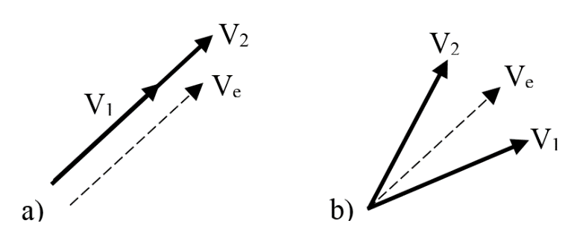

Fig. 1 - Transitioning phasors for a) magnitude step, b) phase step

5) A preliminary evaluation of a laboratory system intended to be a PMU calibrator based on the methods exposed.

In order to analyze the contribution to the uncertainty of calibration systems, we made simulations to obtain the numerical errors of each numerical method. The paper is organized in the following sections: II) mathematical background, where are presented the proposed models for dynamic signals with magnitude or phase steps, the intermediary phasor definitions, the basic concepts of the Hilbert transform and of the NL-LS method; III) Monte Carlo simulations to analyze the numerical errors of each method; IV) Laboratory measurements to evaluate the use of a proposed system for the calibration of PMUs; V) Discussion of results and conclusion.

# Mathematical Background

## Mathematical models for dynamic signals

A pure sinusoidal waveform with one magnitude step, located at can be modeled in continuous time

, (1)

where is the step function. A similar model for the phasor waveform with one phase step is

. (2)

The step function is used as an idealization of a fast transient in magnitude or phase occurring at the instant . Provided a sufficiently accurate estimate of , the set of parameters can then be adjusted to obtain a waveform that best fits the data received by the calibration system sampler, where is the signal nominal magnitude, is a decimal value representing the magnitude change, is the amplitude of the phase step, is the angular frequency, is the initial phase, and represents interfering noise. Given a prescribed signal to noise ratio (SNR) in dB, the amplitude of noise is

- Instant frequency of a signal with magnitude step

(3)

## Reference values

After one estimates the model parameters, the problem of obtaining one phasor that represents the waveform arises. Instead of considering the values estimated from the adjacent windows, one alternative proposal could be an intermediate value for magnitude or phase. The concept is illustrated in Fig. 1, where the phasor represents the waveform during an initial steady state, is a phasor representative of an intermediate state during the occurrence of a magnitude or phase step, and represents the signal in the final steady state condition.

Intermediate phasors can be obtained, for example, using a weighted means out of the model parameters. For any , for a waveform with magnitude step described by (1), the intermediate phasor would be

; (5)

and for a waveform with a phase step test described by (2), the intermediate phasor would be

. (6)

## Hilbert transform

Hilbert transform has been used to estimate instantaneous frequency (IF) of narrowband monocomponent signals, which is the case of electric network phasor components. There are various applications of IF estimation reported in the literature, e.g., characterization of electric disturbances [6] and detection of edits in audio signals that bear the electric network frequency [7]. Anomalous perturbations on the IF can flag the occurrence of discontinuities in the signal. The time instant they happened can be estimated via appropriate amplitude threshold schemes. The concept is shown in Fig. 2 and Fig. 3.

Given a real signal , let be called the analytic signal associated to , defined as

, (7)

where

(8)

is the Hilbert transform of . If is expressed in the polar form

(9)

, (10)

, (11)

the instantaneous frequency (IF) can be defined as

. (12)

The discrete implementation of can be done with fast fourier transform (FFT) … explain how

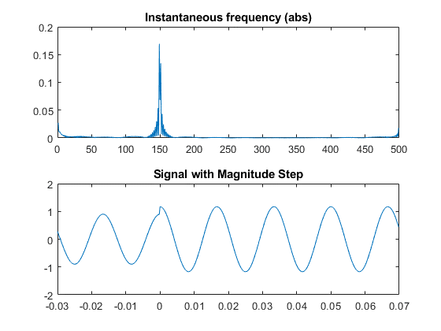

Fig. 2 - Instantaneous frequency of signal with one magnitude step

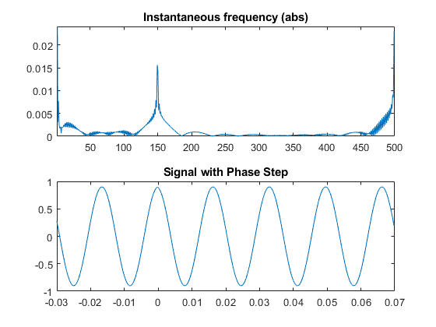

Fig. 3 - Instantaneous frequency of signal with one phase step

## Levenberg-Marquardt

Consider samples from a sequence which can be either generated via computational simulation or sampled from measured real phenomenon, with uniform sampling period . One wishes to fit the models (see Section II) with parameters to For that, one can define the error cost function

, (4)

and try to solve the minimization problem

The estimation of phasor parameters considering variations in frequency requires dealing with a non-linear function. Existing calibration systems solve this problem for steady-state signals through low order Taylor linearization [3], or using directly some non-linear minimization algorithm, e.g., Levenberg-Marquardt (LM) [4].

The Levenberg-Marquardt (LM) algorithm is an iterative technique for nonlinear minimization problems. It combines the Gauss-Newton method and the steepest descent and is very useful when the size of the algorithm step cannot be obtained in a closed form. Such NL-LS methods can reach local minima and need a convex cost function.

# Numerical Simulations

We performed Monte Carlo simulations with 1000 iterations for each set point, to estimate the errors obtained with the numerical computation of the reference values. These errors will be considered as an uncertainty component in the overall process.

The input signals were digitally generated, with all nominal parameters prescribed in the standard and random values representative of expected uncertainties in each parameter. The signals were created based on (1) and (2) with a 5 kHz sampling frequency, with a duration of 0.1 s. The nominal values are summarized in Table I, with their respective uncertainties used in simulations.

Table I- Parameter uncertainties for simulations

|  |  |  |  |  |  |
| --- | --- | --- | --- | --- | --- |
| **Parameter** |  |  |  |  |  |
| **Nominal** | 1 V | ± 0.1 | ± 10° | 60 Hz | 360°, ±120° |
| **d[%]** | 1 | 1 | 1 | 0.05 | 1 |

## Step instant estimation with Hilbert transform

The peaks were detected taking the maximum value of the IF subtracted by its median value. If we use an ideal signal without uncertainties in the parameters and nominal frequency, for a total duration of the window T, , and , the maximum absolute errors are not greater than .

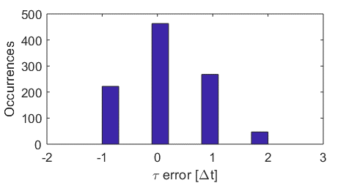

Fig. 4 - Histogram of errors in step instant estimation

In a second simulation, to represent a more realistic situation, we allowed 500 ppm variation in frequency and 1% variation in the other parameters. The maximum errors obtained are not greater than for a . The distribution of occurrences is shown in a histogram in Fig. 4.

## Parameters estimation with non-linear least squares

For each Monte Carlo iteration, is generated with uncertainties added to the parameters, drawn from a uniform distribution centered in the nominal values, as shown in Table I, where **d** is half the interval of the uniform distribution, given in percentage of the nominal values. In the iterative LM algorithm, the model parameters are initiated at the nominal values, and the optimization procedure seeks for the minimum point of which is reached at the actual values of the parameters. The maximum errors obtained are shown in the lower parts of Table I. One can see that, for both tests, the estimation of the step discontinuity parameters are the most sensitive to the SNR. Moreover, they exhibit the highest maximum errors.

|  |  |  |  |  |  |
| --- | --- | --- | --- | --- | --- |
| **SNR** | **Magnitude Step Tests maximum errors [ppm]** | | | | |
| 97 | 0.98 | 12 | - | 0.077 | 0.30 |
| 95 | 0.95 | 15 | - | 0.086 | 0.33 |
| 93.5 | 1.2 | 20 | - | 0.087 | 0.50 |
| 92.5 | 1.5 | 19 | - | 0.087 | 0.53 |
| 90.5 | 1.8 | 32 | - | 0.15 | 0.50 |
| **SNR** | **Phase Step Tests maximum errors [ppm]** | | | | |
| 97 | 0.54 | - | 16 | 0.13 | 0.67 |
| 95 | 0.71 | - | 19 | 0.17 | 0.69 |
| 93.5 | 0.89 | - | 22 | 0.18 | 1.0 |
| 92.5 | 0.96 | - | 23 | 0.18 | 1.2 |
| 90.5 | 1.1 | - | 28 | 0.22 | 1.4 |

The uncertainties of some parameters seem to be correlated. For example, in the phase step test model, the uncertainty in the

angular frequency ( estimation (all other parameters kept constant) has a quadratic relation with the maximum error obtained for the magnitude parameter , as shown in Fig. 1.

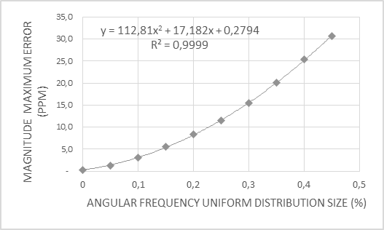

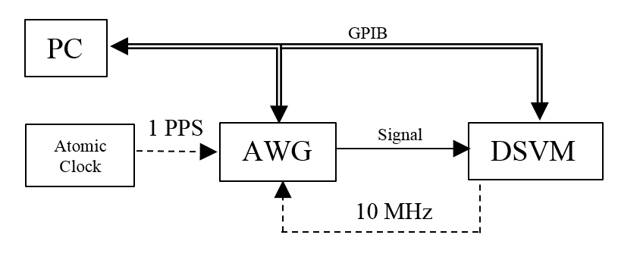

Fig. 7 - Block Diagram

## Estimation of intermediate phasors

For signals digitally generated with the uncertainties indicated in Table I, and also considering maximum errors of ± in the estimation of , the intermediate phasors calculated with (5) and (6) were compared to nominal values to obtain magnitude and phase maximum errors.

The maximum errors obtained in the estimation of magnitude were not greater than 2.5 ppm with , in every prescribed situation. There is some sensitivity to noise, shown in Fig. 5 and Fig. 6, in function of the step occurrence.

The phase error was not greater than degrees.

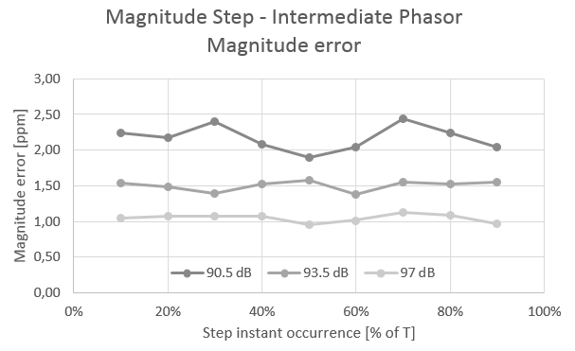

Fig. 5 – Intermediate phasor - maximum magnitude errors obtained for magnitude step tests.

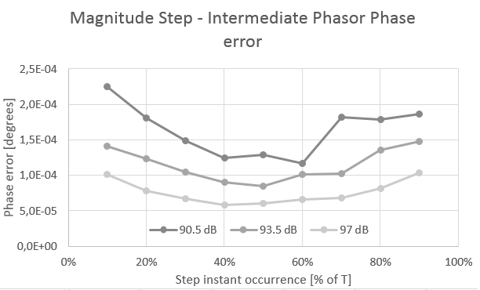

Fig. 6 – Intermediate phasor - maximum phase errors obtained for magnitude step tests.

# Laboratory measurements

Aiming at validating the proposed method with real signals, several measurements were made using one digital sampling voltmeter (DSVM) and one arbitrary waveform generator (AWG), controlled by a personal computer (PC) via GPIB. The connections are shown in the block diagram of Fig. 7.

The same waveforms used in simulations are reproduced by the AWG, with a nominal output of 1 Vpp, and sampled by the DSVM. Both are triggered with a 1 PPS (pulse per second) signal, coming from an atomic clock, so we can control the initial phase. The internal clock from the DVM is used as an external 10MHz reference signal by the generator. 5000 samples are taken during 1 s and stored in the DVM´s internal memory.

The standard [1] establishes that the synchrophasors must be obtained related to the center of a window. Setting 500 samples/window, the first complete window will happen after 250 samples, after which we have 9 windows containing 6 cycles of 60Hz. The steps of magnitude or phase occur in the 5th window, as shown in Fig. 8. According to the procedure for equivalent sampling, the instants of occurrence of the steps are a set of equally spaced intervals .

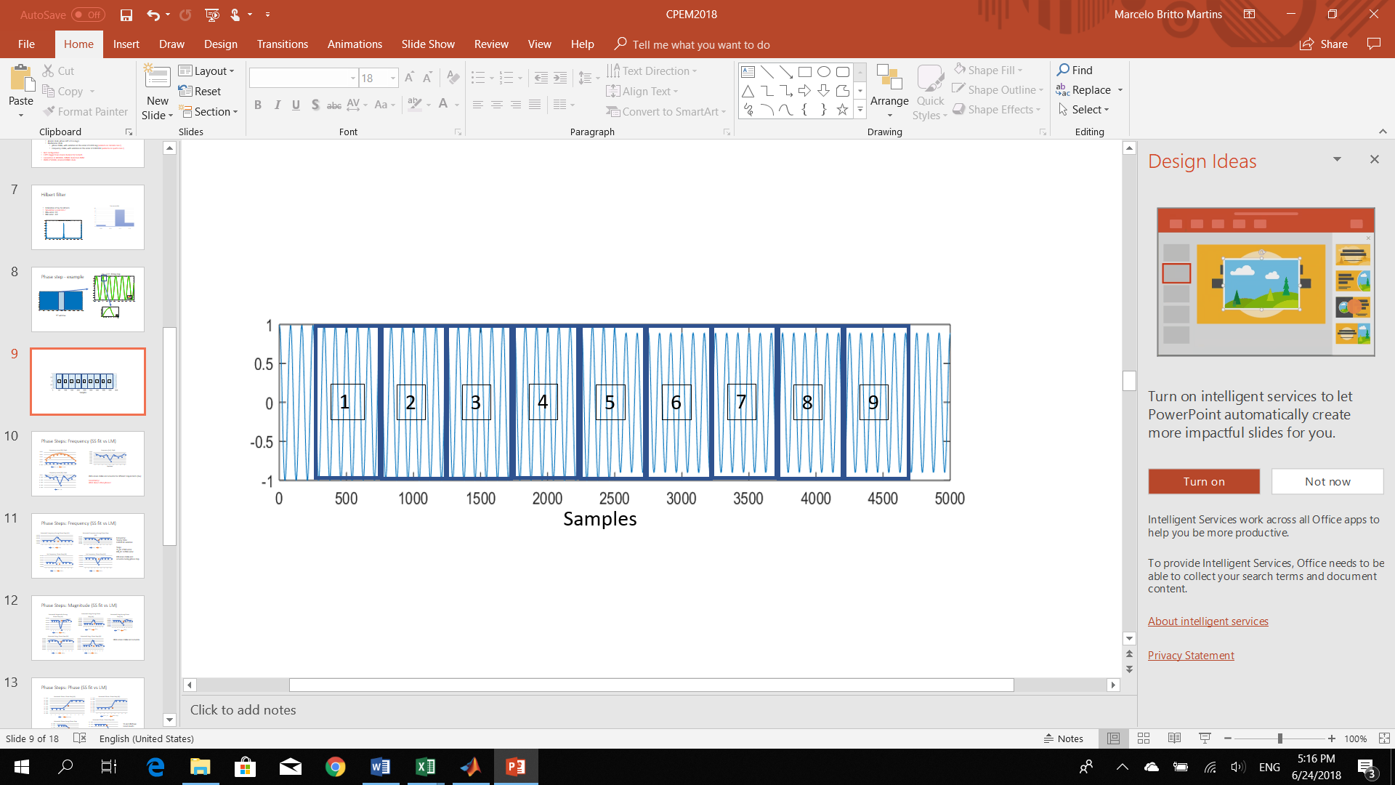

Fig. 8 - Magnitude step occurrence in the 5th window

For the windows with steady state waveforms, the same fitting algorithm used in [3] is used to obtain the synchrophasors and frequency estimates. Comentar da estabilidade neste estado?

For the 5th window, the intermediate phasors were calculated using (5) and (6), after obtaining the parameters using the Hilbert algorithm for the step instant, and the-LM algorithm for the others. The frequency was obtained directly from the LM estimation.

The estimates of step instant were not greater than 2, inside the expected uncertainty. The other parameters require a more detailed analysis.

Histogram?

## Magnitude Steps

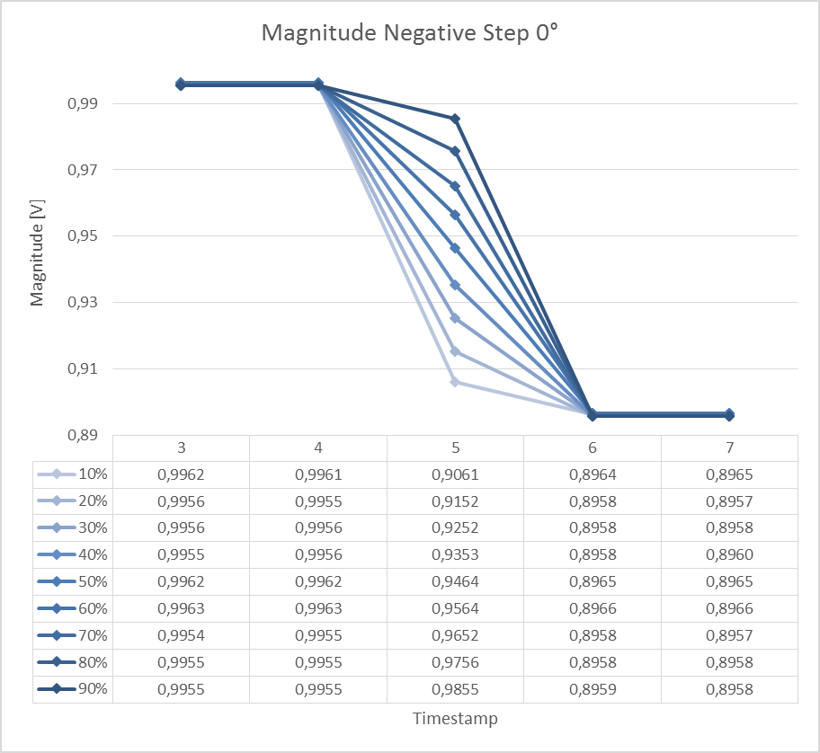

# Conclusion

Models for phasor signals disturbed by magnitude and phase step discontinuity were proposed, in the context of assessment of PMU calibration systems in transient conditions. Estimation of the model parameters via a nonlinear least-squares method was outlined. The proposed approach tackles the estimation of the step discontinuities in the phasor signal observed within an analysis window, instead of dodging the problem. Moreover, single phasor parameters are proposed for transient conditions.

The estimation accuracy of each parameter was obtained under different noise conditions and uncertainties forced upon the model used to generate the test signals. Cross-correlated uncertainties were found, which point out to the need of a deeper investigation and the possibility of further improvements in the estimation performance.

Within the limits reported, the proposed method can give reliable and accurate results to be used in PMU calibration systems, avoiding procedures to adjust windows and time-stamps around the instant of step occurrence.

Acknowledgment

I would like to thank Allen Goldstein, for the valuable comments and guidelines.

References

[1] *IEEE Standard for Synchrophasor Measurements for Power Systems*, IEEE Std C37.118.1-2011*,* Dec. 2011

[2] D. Colangelo *et al*., "Architecture and characterization of a calibrator for PMUs operating in power distribution systems," *2015 IEEE Eindhoven PowerTech*, Eindhoven, 2015.

[3] Y. H. Tang, G. N. Stenbakken and A. Goldstein, "Calibration of Phasor Measurement Unit at NIST," in *IEEE Transactions on Instrumentation and Measurement*, vol. 62, no. 6, pp. 1417-1422, June 2013.

[4] FRIGO, Guglielmo et al., “Definition of accurate reference synchrophasors for static and dynamic characterization of PMUs.” in *IEEE Transactions on Instrumentation and Measurement*, vol. 66, n. 9, p. 2233-2246, 2017.

[5] ESTE MESMO

[6] Caciotta, M., et al. "Detection of short transients and interruptions using the Hilbert transform." in *Proc. 19th IMEKO World Congr. Fundam. Appl. Metrol.. 2009*.

[7] Edit Detection in Speech Recordings via Instantaneous Electric Network Frequency Variations

Referencias de Guilherme e renata, na parte de incertezas estimadas

Ver outras

**First A. Author** (M’76–SM’81–F’87) and all authors may include biographies. Biographies are often not included in conference-related papers. This author became a Member (M) of IEEE in 1976, a Senior Member (SM) in 1981, and a Fellow (F) in 1987. The first paragraph may contain a place and/or date of birth (list place, then date). Next, the author’s educational background is listed. The degrees should be listed with type of degree in what field, which institution, city, state, and country, and year the degree was earned. The author’s major field of study should be lower-cased.

The second paragraph uses the pronoun of the person (he or she) and not the author’s last name. It lists military and work experience, including summer and fellowship jobs. Job titles are capitalized. The current job must have a location; previous positions may be listed without one. Information concerning previous publications may be included. Try not to list more than three books or published articles. The format for listing publishers of a book within the biography is: title of book (publisher name, year) similar to a reference. Current and previous research interests end the paragraph.

The third paragraph begins with the author’s title and last name (e.g., Dr. Smith, Prof. Jones, Mr. Kajor, Ms. Hunter). List any memberships in professional societies other than the IEEE. Finally, list any awards and work for IEEE committees and publications. If a photograph is provided, it should be of good quality, and professional-looking. Following are two examples of an author’s biography.

**Second B. Author** was born in Greenwich Village, New York, NY, USA in 1977. He received the B.S. and M.S. degrees in aerospace engineering from the University of Virginia, Charlottesville, in 2001 and the Ph.D. degree in mechanical engineering from Drexel University, Philadelphia, PA, in 2008.

From 2001 to 2004, he was a Research Assistant with the Princeton Plasma Physics Laboratory. Since 2009, he has been an Assistant Professor with the Mechanical Engineering Department, Texas A&M University, College Station. He is the author of three books, more than 150 articles, and more than 70 inventions. His research interests include high-pressure and high-density nonthermal plasma discharge processes and applications, microscale plasma discharges, discharges in liquids, spectroscopic diagnostics, plasma propulsion, and innovation plasma applications. He is an Associate Editor of the journal *Earth*, *Moon*, *Planets*, and holds two patents.

Dr. Author was a recipient of the International Association of Geomagnetism and Aeronomy Young Scientist Award for Excellence in 2008, and the IEEE Electromagnetic Compatibility Society Best Symposium Paper Award in 2011.

**Third C. Author, Jr.** (M’87) received the B.S. degree in mechanical engineering from National Chung Cheng University, Chiayi, Taiwan, in 2004 and the M.S. degree in mechanical engineering from National Tsing Hua University, Hsinchu, Taiwan, in 2006. He is currently pursuing the Ph.D. degree in mechanical engineering at Texas A&M University, College Station, TX, USA.

From 2008 to 2009, he was a Research Assistant with the Institute of Physics, Academia Sinica, Tapei, Taiwan. His research interest includes the development of surface processing and biological/medical treatment techniques using nonthermal atmospheric pressure plasmas, fundamental study of plasma sources, and fabrication of micro- or nanostructured surfaces.

Mr. Author’s awards and honors include the Frew Fellowship (Australian Academy of Science), the I. I. Rabi Prize (APS), the European Frequency and Time Forum Award, the Carl Zeiss Research Award, the William F. Meggers Award and the Adolph Lomb Medal (OSA).

1. This paragraph of the first footnote will contain the date on which you submitted your paper for review. It will also contain support information, including sponsor and financial support acknowledgment. For example, “This work was supported in part by the U.S. Depart­ment of Com­merce under Grant BS123456.”

   The next few paragraphs should contain the authors’ current affiliations, including current address and e-mail. For example, F. A. Author is with the National Institute of Standards and Technology, Boulder, CO 80305 USA (e-mail: author@ boulder.nist.gov).

   S. B. Author, Jr., was with Rice University, Houston, TX 77005 USA. He is now with the Department of Physics, Colorado State University, Fort Collins, CO 80523 USA (e-mail: author@lamar.colostate.edu).

   T. C. Author is with the Electrical Engineering Department, University of Colorado, Boulder, CO 80309 USA, on leave from the National Research Institute for Metals, Tsukuba, Japan (e-mail: author@nrim.go.jp).